**VISVESVARAYA TECHNOLOGICAL UNIVERSITY**

**“Jnana Sangama”, Belagavi-590018**

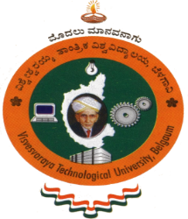

**A DBMS Laboratory Mini Project Report**

**On**

**“IRCTC RAILWAY RESERVATION”**

**SUBMITTED IN PARTIAL FULFILLMENT FOR 5TH SEMESTER**

**BACHELOR OF ENGINEERING**

**IN**

**COMPUTER SCIENCE AND ENGINEERING**

**Submitted by**

**SHASHIDHAR A S (1JB20CS113)**

**SUCHITH KUMAR G M (1JB20CS124)**

**Under the Guidance of:**

**Mrs. PRAKRUTHI M K**

**Assistant Professor,**

**Dept. Of CSE, SJBIT**

**Department of computer science and engineering**

**SJB Institute of Technology**

**BGS Health and Education city,**

**Kengeri,Bengaluru-560060,Karnataka, India**.

**2022-2023**

**|| Jai Sri Gurudev ||**

**Sri Adichunchanagiri Shikshana Trust ®**

**SJB INSTITUTE OF TECHNOLOGY**

No.67, BGS Health & Education City, Dr. Vishnuvardhan Rd, Kengeri, Bengaluru, Karnataka 560060

**Department of Computer Science and Engineering**

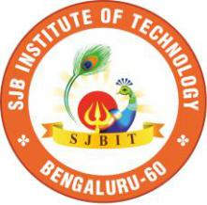

**CERTIFICATE**

Certified that the DBMS Mini Project entitled “**IRCTC RAILWAY RESERVATION**” carried out by **Shashidhar A S, Suchith Kumar G M** bearing USN **1JB20CS113 and 1JB20CS124** are bonafide students of **SJB Institute of Technology** in partial fulfilment for 5th Semester of **BACHELOR OF ENGINEERING** in **COMPUTER SCIENCE AND ENGINEERING** of the **Visvesvaraya Technological University**, **Belagavi** during the academic year **2022-23.** It is certified that all corrections/suggestions indicated for Internal Assessment have been incorporated in the Report deposited in the Departmental library. The mini project report has been approved as it satisfies the academic requirements in respect of mini project prescribed for the said Degree.

**Signature of Guide** **Signature of HOD**

|  |  |
| --- | --- |
| **Mrs. Prakruthi M K** | **Dr. Krishna A N** |
| **Assistant professor** | **Professor & Head** |
| **Dept. of CSE, SJBIT** | **Dept. of CSE, SJBIT** |

**Internal Examiner**

**External Examiner**

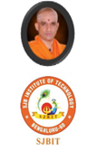

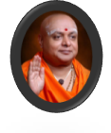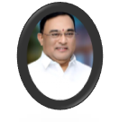

**ACKNOWLEDGEMENT**

We would like to express our profound grateful to His Divine Soul **Jagadguru Padmabhushan Sri Sri Sri Dr. Balagangadharanatha Mahaswamiji** and His Holiness **Jagadguru Sri Sri Sri Dr. Nirmalanandanatha Mahaswamiji** for providing us an opportunity to complete ouracademics in this esteemed institution.

We would also like to express our profound thanks to **Revered Sri Sri Dr. Prakashnath Swamiji**, Managing Director, SJB Institute of Technology, for his continuous support inproviding amenities to carry out this Mini Project in this admired institution.

We express our gratitude to **Dr. K. V. Mahendra Prashanth,** Principal, SJB Institute of Technology, for providing us an excellent facility and academic ambience; which have helped us in satisfactory completion of Mini Project work.

We extend our sincere thanks to **Dr. Krishan A N,** Head of the Department, Computer Science and Engineering for providing us an invaluable support throughout the period of our Mini project work.

We wish to express our heartfelt gratitude to our guide **Prakruthi M K,** for her valuable guidance, suggestions and cheerful encouragement during the entire period of our Mini Project work.

Finally, we take this opportunity to extend our earnest gratitude and respect to our parents, Teaching & Non teaching staffs of the department, the library staff and all our friends, who have directly or indirectly supported us during the period of our Mini Project work.

Regards,

Shashidhar A S [1JB20CS113]

Suchith Kumar G M [1JB20CS124]